Scoring Notation

A correctly answered toss-up question. | 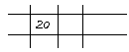
A missed toss-up question. | 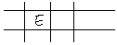
A correctly answered bonus question (Record 10 pts. for Team Points). | 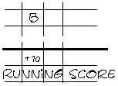
A missed bonus question.  (No error recorded.) | 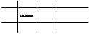
The 4th correct toss-up question by one individual (without errors). | 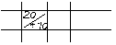
The 3rd error on toss-up questions by one individual. | 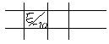
A correctly answered toss-up question by a 3rd, 4th or 5th individual.  (Record 10 pts. for Team Points) | 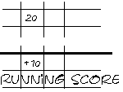
Cross check the running score with the sum of the individual scores plus the Team points. They must be equal. | 